Module 5
OpenMP
OpenMP is an application programming interface (API) that supports multi-platform shared-memory multiprocessing programming in C, C++, and Fortran on many platforms.
OpenMP is an Application Programming Interface (API) for shared-memory parallel programming in C, C++, and Fortran.
It uses a set of compiler directives, library routines, and environment variables to enable developers to write parallel applications that can run on multiple processors or cores, improving performance and reducing execution time.
OpenMP works by allowing a program to run in parallel on multiple threads, which are then synchronized and joined back together to the master thread.
Key Concepts of OpenMP
1. Parallel Regions: Code blocks specified as parallel are executed by multiple threads concurrently.
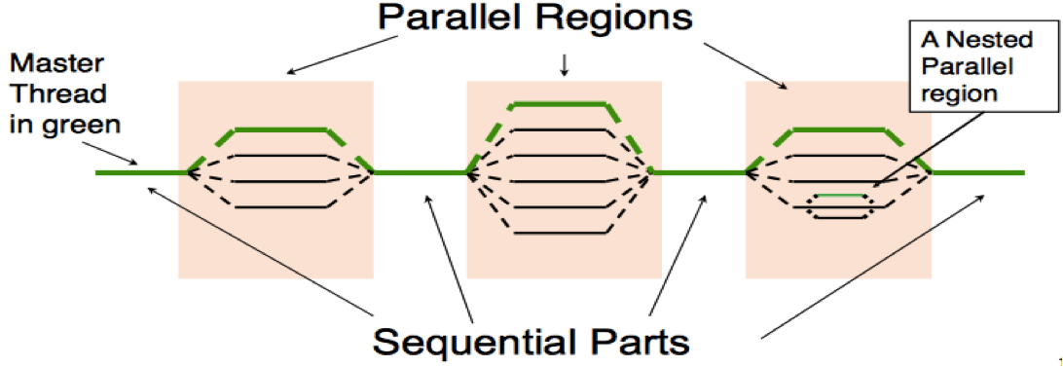
Example:
#include <omp.h>
#include <stdio.h>
int main() {
#pragma omp parallel
{
printf("Hello from thread %d\n", omp_get_thread_num());
}
return 0;
}
2. Thread-based Parallelism: Thread-based parallelism is a programming model where multiple threads are created to execute tasks concurrently. Each thread performs a part of the overall task, enabling the program to utilize multiple processor cores simultaneously for faster execution.
How It Works:
- The main program creates multiple threads.
- These threads execute in parallel, sharing the system’s CPU resources.
- The workload is divided among the threads so that each one handles a specific portion.
- Once the tasks are complete, threads may synchronize to combine results or continue with dependent operations.
3. Data Environment: When multiple threads run in parallel, variables can either be shared or private:
Shared variables: One copy exists that all threads use and can see changes.
Private variables: Each thread gets its own separate copy, so changes by one thread don't affect others.
4. Synchronization: OpenMP provides synchronization constructs like
- critical: Only one thread at a time can run the code inside the critical section (like a lock).
- barrier: All threads wait here until every thread has reached this point, ensuring synchronization.
- atomic: A lightweight way to ensure a single operation on a variable is done atomically to avoid conflicts.
5. Task Parallelism: OpenMP allows creation of tasks that can run asynchronously (not necessarily all at the same time), enabling flexible and dynamic scheduling of units of work. Tasks help manage parallelism when workloads are irregular or dynamic, as OpenMP can decide when to run each task.

Main Goals of OpenMP and How They Are Achieved
- Simplify Parallel Programming: OpenMP simplifies the process of converting a sequential program into a parallel one by using compiler directives like #pragma omp. These directives allow developers to enable parallel execution with minimal changes to the existing code.
- Portability: OpenMP programs can run on various shared-memory architectures without modification. This feature ensures that the same code works across different hardware setups, promoting portability.
- Scalability: OpenMP automatically adjusts to the available number of cores or threads on a system. This allows programs to efficiently scale their performance as more processing resources become available, without the need for manual reconfiguration.
- Maintainability and Debuggability: By using high-level constructs instead of complex threading APIs, OpenMP makes it easier to read, modify, and debug parallel code. This reduces development effort and potential errors.
- Efficient Resource Utilization: OpenMP uses work-sharing and dynamic scheduling constructs to evenly distribute tasks among threads. This ensures that computing resources are used efficiently and minimizes idle time among threads.
Aspect | OpenMP | MPI | CUDA
Architecture | Shared-memory parallelism | Distributed-memory parallelism via message passing | GPU-accelerated parallelism for massive SIMD
Ease of Programming | High; uses compiler directives | Moderate; explicit message passing | Low; requires detailed GPU kernel programming
Scalability | Limited to single multi-core/shared-memory node | Highly scalable across compute clusters | Scales on GPUs, limited by GPU memory and complexity
Synchronization | Built-in synchronization constructs | Explicit synchronization | Synchronization within GPU threads only
Typical Use Case | Parallel loops, moderate scale | Large-scale distributed computing | Data-parallel GPU tasks like image processing
Performance | Good on multi-core CPUs, less suitable for very large clusters | High for distributed systems | Very high for SIMD tasks on GPU

Advantages and Disadvantages of OpenMP with Real-World Examples
Advantages:
Simplicity and Ease of Use: Minimal code changes with pragmas enable quick parallelization. For example, an image processing application was parallelized with just a few OpenMP directives improving performance 2-3x on a multi-core CPU.​
Portability: Runs on any platform with OpenMP support without hardware dependency (unlike CUDA's GPU requirement).​
Incremental Parallelism: Developers can parallelize parts of an existing sequential codebase incrementally without full rewrites.​
Fast Data Sharing: Shared memory allows low-latency communication among threads, beneficial for tightly coupled tasks like matrix multiplication.​

Disadvantages:
Limited Scalability: Works effectively only on shared memory systems limiting size of parallelism, unlike MPI that scales across clusters.​
No GPU Support: OpenMP does not natively utilize GPUs, limiting performance for highly parallel data-intensive tasks which CUDA excels at.​
Synchronization Bugs: Programmers must manage synchronization, risking deadlocks or race conditions in complex code.​
Performance Bottlenecks: Memory architecture and cache coherence overheads may limit speedups on large datasets compared to distributed memory models.​

fork-join model of parallel computing
- The Fork-Join model is the core execution model used in OpenMP to enable parallelism. It begins with a single master thread, which runs the program sequentially until it encounters a parallel region.
- Fork Phase: When the program reaches a parallel block (e.g., #pragma omp parallel), the master thread forks a team of worker threads. All threads, including the master, then execute the code inside the parallel region concurrently. The number of threads created depends on system settings or user-defined configuration (like omp_set_num_threads() or OMP_NUM_THREADS).
- Join Phase: After the parallel region is completed, all worker threads join back with the master thread. At this point, only the master thread continues executing the remaining sequential part of the program.
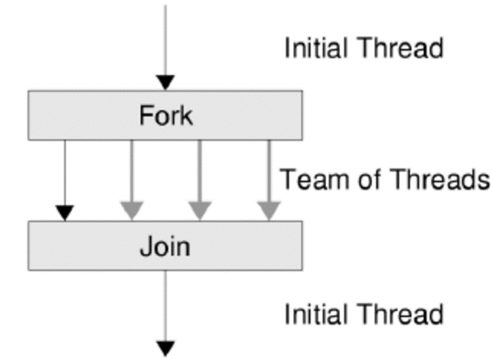
- This model enables developers to parallelize specific sections of code while keeping the rest of the program simple and serial. It's efficient for tasks like loop parallelism and data processing, where sections of code can be executed independently across multiple threads.

Supported Platforms and Compilers
Supported Platforms:
1. Linux,
2. Windows,
3. macOS
Compilers Supporting OpenMP:
1. GCC (GNU Compiler Collection):
- GCC support for OpenMP directives, enabling developers to parallelize C, C++, and Fortran code using OpenMP pragmas.
- The compiler recognizes #pragma omp directives and translates them into multi-threaded code that runs efficiently on shared-memory architectures.
- GCC provides options such as -fopenmp during compilation to enable OpenMP support. This flag links the OpenMP runtime library and enables parallel code generation.
- GCC’s implementation supports multiple versions of the OpenMP specification, with continuous improvements to support newer features and extensions.
- It compiles code across platforms like Linux, macOS, and Windows (via MinGW), making it widely accessible for OpenMP development.

2. Intel C/C++ Compiler: The Intel C/C++ Compiler (including the Intel oneAPI DPC++/C++ Compiler) provides comprehensive and optimized support for OpenMP, targeting Intel architectures and others.
- It recognizes #pragma omp directives and generates highly optimized multi-threaded code for shared-memory systems, leveraging Intel-specific hardware features such as Hyper-Threading.
- To enable OpenMP, use compilation options like -qopenmp or -fiopenmp (both equivalent), which enable OpenMP runtime linking and parallel code generation.
- Intel's compiler supports OpenMP versions up to 5.2 and includes Intel-specific OpenMP extensions for advanced parallel programming features.
- The compiler supports ahead-of-time (AOT) and just-in-time (JIT) compilation for CPUs and GPUs, enhancing portability and performance.
- It primarily targets Intel platforms but is compatible with Linux, Windows, and macOS environments as well.

3. Clang/LLVM:
- The Clang front end combined with LLVM backend supports OpenMP by translating OpenMP pragmas into calls to the LLVM OpenMP runtime library.
- The compiler requires specific flags such as -fopenmp to enable OpenMP processing during compilation.
- Clang supports OpenMP 4.5 features and partially support later versions, though some advanced features might still be under development or less mature compared to GCC and ICC.
- The LLVM OpenMP runtime is cross-platform and supports Linux, Windows, and macOS, making Clang a versatile choice for OpenMP development on different systems.
- Clang’s modular design allows integration with various debugging and profiling tools, useful for developing and optimizing OpenMP parallel programs.

4. MS Visual C++: Microsoft's compiler supports OpenMP features on Windows environments, providing good integration with Windows development tools.

limitations of OpenMP across platforms
OpenMP has some limitations across platforms, especially related to scalability, memory architecture, and runtime behavior:
Limited Scalability: OpenMP is designed for shared-memory systems and is constrained by the number of CPU cores available on a single machine. It does not scale well across distributed systems or multiple nodes like MPI or GPU-accelerated models (CUDA) can.​
Shared Memory Bottlenecks: While N processors in a symmetric multiprocessing system can provide proportional computation power, memory bandwidth does not scale linearly. Multiple processors sharing the same memory path can cause contention and performance degradation as they compete for bandwidth.​
Load Balancing and Synchronization Overhead: OpenMP programs can face issues with load imbalance among threads and synchronization overhead, which reduces performance gains. The default static scheduling can cause threads to finish at different times, causing delays.​
Thread Affinity and Migration: Threads may migrate between processor cores unless explicitly pinned, leading to higher context-switching costs and reduced cache locality. This affects performance particularly when threads move across different cores or sockets.​
Program Complexity and Debugging: OpenMP can introduce synchronization bugs, race conditions, and false sharing, which are difficult to detect and debug.​
Compiler and Runtime Variability: Performance and feature support can vary between compilers and OpenMP runtime implementations, which may cause inconsistencies across platforms.​
Implicit Barriers and Directive Restrictions: OpenMP has implicit synchronization barriers that may limit parallelism and prohibits certain directive nesting, impacting program design flexibility.​

Components of OpenMP API
- Compiler Directives (Pragmas)
  - Special instructions (e.g., #pragma omp parallel) inserted into code.
  - Tell the compiler how to parallelize specific sections.
  - Control parallel regions, loops, data sharing, synchronization, etc.
e.g.
#pragma omp parallel
{
printf("Hello from thread %d\n", omp_get_thread_num());
}
- This directive creates a parallel region where multiple threads execute the block concurrently.
- Runtime Library Routines: OpenMP runtime routines provide programmatic control over threading behavior and querying of the OpenMP environment:
a) Thread Identification and Count:
omp_get_thread_num() returns the thread’s unique ID in the current team.
omp_get_num_threads() returns the total number of threads in the current parallel region.
b) Setting Thread Count:
omp_set_num_threads(int n) sets the number of threads for upcoming parallel regions (must be called outside parallel regions).
c) Timing:
omp_get_wtime() returns wall clock time for performance measurement.
d) Nested Parallelism:
omp_get_nested() checks if nested parallelism is enabled.
omp_set_nested(int) enables or disables nested parallel regions.
e) Dynamic Threads:
omp_get_dynamic() and omp_set_dynamic() control whether OpenMP can dynamically adjust the number of threads.
- Environment Variables
  - They influence the execution behavior of the OpenMP program without modifying code. Common environment variables control the number of threads, thread affinity, scheduling, and nested parallelism.
  - Examples:
    - OMP_NUM_THREADS: sets number of threads.
    - OMP_SCHEDULE: controls loop scheduling.
Interaction between directives, runtime routines, and environment variables: The three components complement each other in OpenMP execution:
    - Directives provide structural instructions for parallelism directly in the code.
    - Runtime routines allow programs to query and modify execution parameters dynamically during runtime, providing adaptability.
    - Environment variables set default or overriding policies externally, enabling users or administrators to tune performance without recompilation.
    - For example, if OMP_NUM_THREADS is set in the environment, it defines the default thread count. However, a program can override this inside the code by calling omp_set_num_threads(). Meanwhile, parallel regions controlled by #pragma omp parallel directives use these thread counts accordingly. Similarly, scheduling policies set via OMP_SCHEDULE can be overridden by schedule clauses in directives.

OpenMP Program Structure
The syntax of a parallel region directive in C using OpenMP:
#pragma omp parallel
{
// code to run in parallel
}

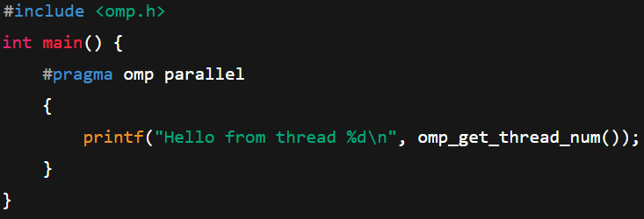
General code layout:
  - Include header <omp.h>
  - Use #pragma omp directives
Core Syntax and Structured Blocks

#pragma omp parallel – start of a parallel region
#pragma omp for – parallel for-loop
#pragma omp sections – divide tasks among threads
#pragma omp single – execute block by only one thread
#pragma omp critical – protect shared data

E.g:
#include <stdio.h>
#include <omp.h>

int main() {
#pragma omp parallel
{
printf("Hello from thread %d\n", omp_get_thread_num());
}
return 0;
}
Structured Blocks
A structured block sequence that consists of no statements or more than one statement may appear only for executable directives that explicitly allow it. The corresponding compound statement obtained by enclosing the sequence in { and } must be a structured block and the structured block sequence then should be considered to be a structured block with all of its restrictions.

Aspect | Structured Parallelism | Unstructured Parallelism
Definition | Structured parallelism involves parallel regions explicitly defined by the programmer with predetermined start and end points. | Unstructured parallelism creates parallel tasks dynamically during execution without fixed boundaries.
Examples | Examples include parallel loops using #pragma omp parallel for and dividing work with #pragma omp sections. | Examples include task-based parallelism using #pragma omp task for irregular or recursive workloads.
Control | The programmer controls where parallelism starts and ends with OpenMP directives. | The runtime system dynamically schedules tasks created at runtime.
Use Case | Typically used for regular and predictable workloads like data-parallel loops. | Used for irregular, recursive, or dynamic workloads where tasks are created on the fly.
Debugging | Easier to debug because of the clearly structured and deterministic execution flow. | More difficult to debug due to asynchronous execution and dynamic task creation

Compiling OpenMP Programs
OpenMP (Open Multi-Processing) is an API that supports multi-platform shared memory multiprocessing programming in C, C++, and Fortran. To use OpenMP features, the program must be compiled with specific compiler flags, and thread support can be verified using built-in OpenMP functions.
Compile using OpenMP flags:
GCC: Enable OpenMP for C/C++/Fortran:
gcc -fopenmp program.c -o output
g++ -fopenmp program.cpp -o output
gfortran -fopenmp program.f90 -o output
Intel: Enable OpenMP:
icc -qopenmp program.c -o output
icpc -qopenmp program.cpp -o output
ifort -qopenmp program.f90 -o output

Clang/LLVM:For Clang (requires OpenMP runtime):
clang -fopenmp=libomp program.c -o output
clang++ -fopenmp=libomp program.cpp -o output
(On some systems, plain -fopenmp may be sufficient if configured for libomp)

Steps to Compile and Execute an OpenMP Program (Using GCC)
1. Write the source code:
Include OpenMP header: #include <omp.h>
Example directive: #pragma omp parallel

2. Compile with OpenMP support: Use the -fopenmp flag to enable recognition of OpenMP pragmas and link against the OpenMP runtime.
3. Run the executable: Control the number of threads at runtime using environment variables.
4.Check thread usage: Use OpenMP functions like omp_get_max_threads(), omp_get_thread_num() inside your code to verify thread support.
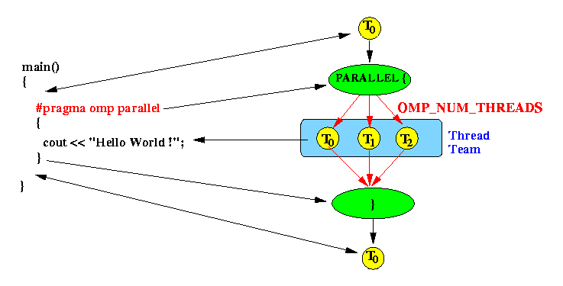

Compiler Options for Different Languages and Platforms
Compiler | C/C++ Example | Fortran Example
GCC | gcc -fopenmp file.c | gfortran -fopenmp file.f90
Intel | icc -qopenmp file.c | ifort -qopenmp file.f90
Clang/LLVM | clang -fopenmp=libomp file.c | N/A or use flang/flink [for new Fortran tool]

Compiling OpenMP Programs: C, C++, and Fortran Differences
C: Use gcc with -fopenmp, include <omp.h>, directives like #pragma omp.
C++: Use g++ with -fopenmp, same header and pragma syntax as C.
Fortran: Use gfortran with -fopenmp, and compiler-specific comment-based directives (!$omp).
All three require inclusion of the proper header/library and compatible compiler options.

Linking and Execution
GCC and Clang auto-link OpenMP runtime:
The -fopenmp flag automatically links your code with GCC’s libgomp or LLVM’s libomp, ensuring multi-threaded support.​
Intel compilers:
Use -qopenmp for both compile and link steps.
Executable behavior:
The OpenMP runtime handles thread management, work-sharing, and synchronization at execution.
Environment variables such as OMP_NUM_THREADS configure thread counts per execution.
Common Compilation Errors and Solutions
Error | Cause | Solution
undefined reference to omp_* | Missing -fopenmp flag | Add -fopenmp to compile & link steps
No parallelism observed | Program lacks OpenMP regions, or threads not set | Add #pragma omp directives, set OMP_NUM_THREADS
"Not supported" compiler error | Old or incompatible compiler | Upgrade compiler or use supported version
Clang not linking OpenMP | Missing OpenMP runtime env/config | Use -fopenmp=libomp, install libomp

Parallel region construct
A parallel region in OpenMP is a block of code that is executed by multiple threads concurrently. It is created using the #pragma omp parallel directive. When a parallel region construct is encountered, the master thread forks additional threads (as controlled by settings or environment variables) to execute the code block inside the parallel region. Once the region ends, all threads synchronize and only the master thread continues.

Example: Parallel Region Construct in C/C++
#include <stdio.h>
#include <omp.h>

int main() {
#pragma omp parallel
{
int tid = omp_get_thread_num();
printf("Hello from thread %d\n", tid);
}
return 0;
}
In this example, every thread in the team prints its thread ID. If the environment variable OMP_NUM_THREADS is set to 4 or you include a num_threads clause, four threads will each execute the code and print their messages concurrently. There’s an implicit barrier at the end of the parallel region—execution only continues after all threads have finished their work.

Work is Divided Among Threads Inside a Parallel Region: When an OpenMP parallel region (#pragma omp parallel) is encountered, a team of threads is created, and all threads execute the code block inside the parallel region.
However, if there is work that can be divided, such as iterations of a loop, OpenMP provides work-sharing constructs to split the workload among threads.
The most common work-sharing directive is #pragma omp for, which divides loop iterations evenly or based on a scheduling policy among the threads.

Nested Parallel Regions : Nested parallelism is the ability to create parallel regions inside existing parallel regions.
This means each thread of an outer parallel region can itself spawn a team of threads in an inner parallel region.
Nested parallelism is controlled by environment variables like OMP_NESTED or runtime function omp_set_nested().

Example:
#include <stdio.h>
#include <omp.h>

int main() {
omp_set_nested(1); // Enable nested parallelism

#pragma omp parallel num_threads(2)
{
int tid = omp_get_thread_num();
printf("Outer thread %d\n", tid);

#pragma omp parallel num_threads(3)
{
int inner_tid = omp_get_thread_num();
printf(" Inner thread %d of outer thread %d\n", inner_tid, tid);
}
}
return 0;
}
Parallel Execution of Multiple Tasks
Using #pragma omp sections inside a parallel region, multiple independent tasks can be executed concurrently by different threads.

Example:
#include <stdio.h>
#include <omp.h>
void task1() { printf("Task 1 executed by thread %d\n", omp_get_thread_num()); }
void task2() { printf("Task 2 executed by thread %d\n", omp_get_thread_num()); }
void task3() { printf("Task 3 executed by thread %d\n", omp_get_thread_num()); }
int main() {
#pragma omp parallel sections
{
#pragma omp section
task1();

#pragma omp section
task2();

#pragma omp section
task3();
}
return 0;
}

Creating and Managing Threads

In OpenMP, threads are the basic units of parallel execution. The OpenMP runtime system automatically manages thread creation, execution, and termination — making it easy to write parallel programs.
- OpenMP identifies and manages threads using thread IDs by:
- When a program enters a parallel region, OpenMP creates a team of threads.
- Each thread is assigned a unique ID using omp_get_thread_num().
- The master thread always has ID = 0, while other threads are worker threads.
- Thread management (creation, synchronization, and termination) is automatically handled by the OpenMP runtime system.

1. Automatic Thread Creation in Parallel Regions
- When the compiler encounters a parallel region (using the directive #pragma omp parallel), OpenMP automatically creates a team of threads.
- Each thread executes the same block of code concurrently, allowing multiple parts of the program to run simultaneously on different CPU cores.

2. Default Number of Threads
- By default, the number of threads created in a parallel region equals the number of CPU cores available on the system.
- You can change this number by:
  - Setting the environment variable OMP_NUM_THREADS
  - Calling the function omp_set_num_threads(n)
  - Using the clause num_threads(n) in a directive

3. Important Functions
Function | Purpose
omp_get_thread_num() | Returns the unique ID of the current thread (IDs start from 0).
omp_get_num_threads() | Returns the total number of threads currently running in the parallel region.

4. Nested Parallelism
- Nested parallelism means creating a new parallel region inside an existing parallel region.
- It is disabled by default to prevent unnecessary overhead.
- You can enable it using:
omp_set_nested(1);
- When enabled, each thread in the outer region can create its own team of threads inside an inner parallel region.
e.g: #include <stdio.h>
#include <omp.h>
int main() {
omp_set_num_threads(4); // Create 4 threads
#pragma omp parallel
{
printf("Thread %d is running\n", omp_get_thread_num());
}
return 0;
}

omp_set_num_threads(int n) — sets the number of threads to use in the next parallel region.
#include <stdio.h>
#include <omp.h>

int main() {
omp_set_num_threads(3); // Request 3 threads
#pragma omp parallel
{
printf("Thread %d of %d\n",
omp_get_thread_num(),
omp_get_num_threads());
}
return 0;
}
omp_get_num_threads() — returns the number of threads currently active inside a parallel region.
#include <stdio.h>
#include <omp.h>

int main() {
#pragma omp parallel num_threads(4)
{
int tid = omp_get_thread_num();
printf("Hello from thread %d\n", tid);
}
return 0;
}
Aspect | Static Allocation | Dynamic Allocation
Definition | Fixed number of threads is created at the start of execution. | The number of threads can change during runtime depending on workload or resource availability.
Control | Controlled by omp_set_num_threads() or OMP_NUM_THREADS. | Controlled by omp_set_dynamic(1) to enable OpenMP to decide the thread count dynamically.
Performance | Predictable and consistent performance. | May improve performance in fluctuating workloads but adds overhead.
Use Case | Suitable for uniform workloads. | Suitable for irregular or unpredictable workloads.

Impact of Setting Very Large Thread Counts
- If the number of threads exceeds the number of CPU cores, performance usually degrades instead of improving.
- Reasons:
  - Context switching overhead — CPU spends time switching between threads instead of executing tasks.
  - Increased memory contention — multiple threads compete for shared memory resources.
  - Synchronization delays — more threads cause higher waiting time at barriers or critical sections.
- Optimal performance is generally achieved when:
Number of Threads ≈ Number of CPU Cores
Example:
On an 8-core system, using 32 threads may lead to slower execution than using just 8.
Specifying Number of Threads
Using the num_threads clause:
#pragma omp parallel num_threads(4)
{
// Executes with 4 threads
}
omp_set_num_threads(n) lets you specify the next parallel region’s thread count from within your program code.
Role of OMP_NUM_THREADS Environment Variable: OMP_NUM_THREADS is an environment variable that sets the default number of threads for all OpenMP parallel regions unless specifically overridden.

export OMP_NUM_THREADS=4
./a.out # Runs your program with 4 OpenMP threads by default

Feature | Static Thread Allocation | Dynamic Thread Allocation
How threads assigned | Fixed number, assigned before execution​ | Threads assigned at runtime as available​
Work distribution | Even, pre-determined chunks per thread​ | Work divided into smaller units, threads pick up as free​
Overhead | Low scheduling overhead​ | Higher runtime scheduling overhead​
Best for | Regular workloads, even computation per iteration​ | Irregular workloads, unpredictable computation per iteration​
Load balancing | Poor for irregular tasks, may cause idle threads​ | Good for load balancing, adapts to uneven work​
Directive example | #pragma omp parallel for schedule(static) | #pragma omp parallel for schedule(dynamic)
Typical issues | Possible idle threads if work is uneven​ | Possible overhead with frequent scheduling​

Impact of Excessive Thread Counts
Setting the number of threads far above the available CPU cores typically leads to problems:
- Increased resource contention and overhead from context switching.
- Reduced performance, since threads compete for limited cores.
- Possible instability or errors if the thread count exceeds system or OpenMP runtime limits.
OpenMP Loop Parallelization
OpenMP enables easy parallelization of loops using the #pragma omp parallel for directive. This tells the compiler to split loop iterations across multiple threads that run concurrently. Each thread executes a portion of the loop, reducing overall execution time.
#pragma omp parallel for
for (int i = 0; i < N; i++) {
// loop body executed in parallel
}

Applications of OpenMP
- Scientific Computing and Simulations: OpenMP is heavily utilized in scientific research for simulations involving physics, chemistry, fluid dynamics, and climate modeling. For example, computational electromagnetics codes (like FEKO) and combustion physics solvers use OpenMP for parallelizing numerical computations and simulations on multi-core CPUs.
- Engineering and Automotive: In automotive and aerospace industries, OpenMP accelerates simulations related to aerodynamics, structural analysis, and vehicle design. These applications require intense numerical calculations that benefit from parallel threads.
- Image Processing and Computer Vision: OpenMP helps speed up image manipulation tasks like grayscale conversion, image warping, edge detection, and other complex image transformations by dividing computations across cores. This is crucial in medical imaging and video processing fields.
- Environmental and Fluid Dynamics Modeling: Models simulating water flow, sediment transport, and pollutant dispersion in rivers or oceans employ OpenMP for multi-threading to handle large-scale computational domains efficiently.
- Data Analysis and Computational Biology: OpenMP is used to accelerate algorithms in genome sequencing, protein folding, and complex data analytics that involve large datasets and require fast processing.
- High Performance Computing (HPC) Applications: OpenMP integrates with MPI in hybrid programming models and runs on supercomputers and clusters to parallelize tasks within compute nodes. It enables scalable multi-threaded execution in HPC environments.
Applications of OpenMP
1. Scientific Computing: OpenMP enables parallelization of numerical simulations such as fluid dynamics, climate modeling, and molecular dynamics.
Example: Weather simulation codes use OpenMP to parallelize loop iterations for computing temperature, pressure, and velocity fields, achieving faster results on multi-core processors.
Benefit: Accelerates complex calculations requiring heavy floating-point operations by distributing workload among CPU cores.
2. Matrix Multiplication: Matrix operations are fundamental in linear algebra, machine learning, and graphics.
OpenMP parallelizes nested loops in matrix multiplication to compute parts of the output matrix across multiple threads.
Benefit: Substantial speedup exploiting multi-core CPUs compared to sequential matrix multiplication.
3. Image Processing: Operations like filtering, edge detection, and transformation are data-parallel and easily split across threads. OpenMP parallelizes pixel-level or region-level computations.
Example: Convolution-based filters can be applied in parallel to image segments for real-time performance.
Benefit: Enhances the processing speed in computer vision, medical imaging, and multimedia applications.
4. Data Mining: Large datasets require parallel algorithms for clustering, classification, and association rule mining. OpenMP parallelizes loops over data records or feature sets.
Example: Parallel k-means clustering updates cluster centroids using OpenMP to accelerate iterations.
Benefit: Reduces execution time of computationally intensive data analysis workflows, enabling faster insights.

